
Installation Guide and How to get started with the FRDM-KL25Z in MCUXpresso
Advanced Embedded Systems

Authors: Dr. Gilberto Ochoa Ruiz
Msc. Jorge German Perez Blanco
Contents
Introduction: 2
Environment set up: 2
Installing the SDK in the IDE 5
Running an example to check for proper installation. 7
Annexes 9
Example application code 9

Introduction:
In this tutorial we are going to learn how to install and configure the IDE MCUXpresso, developed by NXP, manufacturer of the Freedom Development Board FRDM-KL25Z, and run a simple application to verify that the procedure was successful.

Environment set up:
The first step is the installation of the IDE (MCUXpresso) and the Software Development Kit (KSDK) downloaded from the manufacturer's site. It's worth noting that you must create an account before you can access any downloads on the manufacturer website.
The IDE can be obtained through the following link:
https://www.nxp.com/design/software/development-software/mcuxpresso-software-and-tools-/mcuxpresso-integrated-development-environment-ide:MCUXpresso-IDE?tid=vanMCUXPRESSO/IDE. Scroll down until you reach the download section (see next picture). Hit the download button beside the IDE’s name. Then select the version, according to your host computer Operating System.
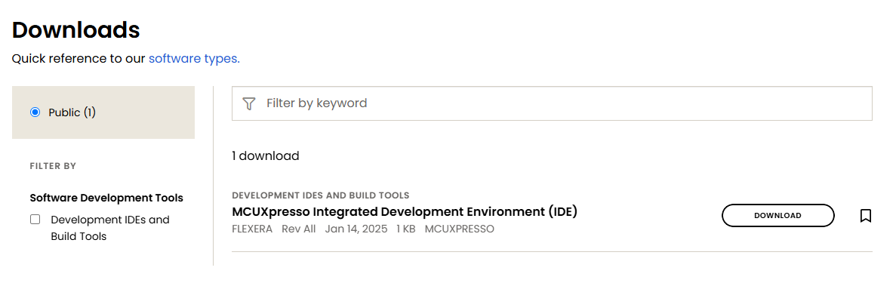

The KSDK can be obtained through the following link: https://mcuxpresso.nxp.com/en/welcome. Click on “Select Development board” option (see next picture).


Then you must select your board, type on the filter the next string: “FRDM-KL25Z” and choose the first option (see next picture).
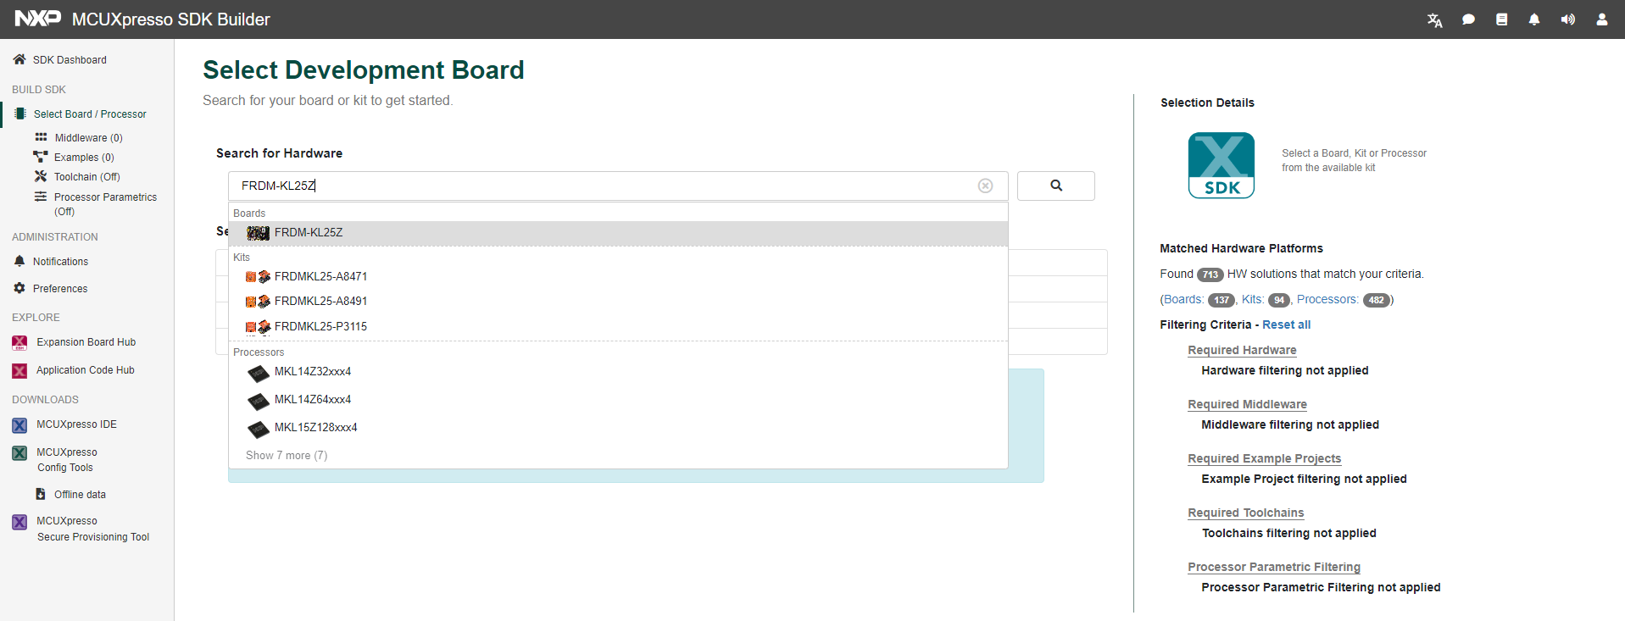

Then hit on the “Build SDK” button as shown in the next picture.
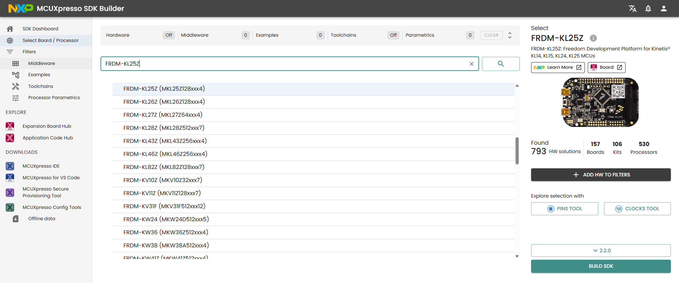

Next you can select all the middlewares that you need to install with your SDK, and finally click on the “Build SDK” button again (see next picture).
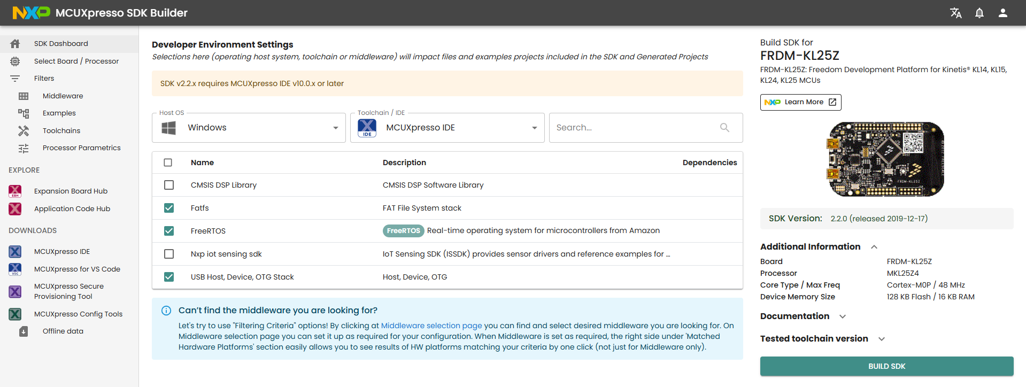
c
Next, you must hit on the “Download” button as shown in the next picture.
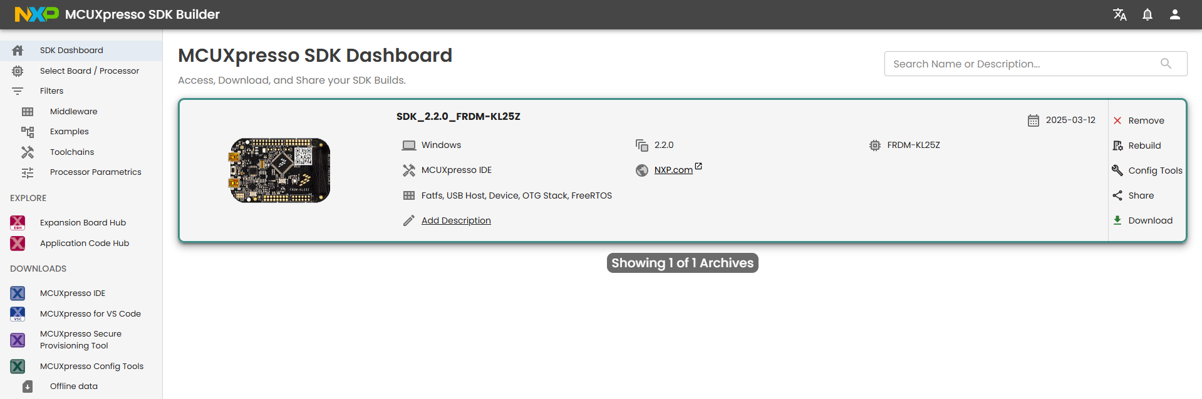
c
Finally, hit on the "Download SDK Archive” option as shown in the next picture.
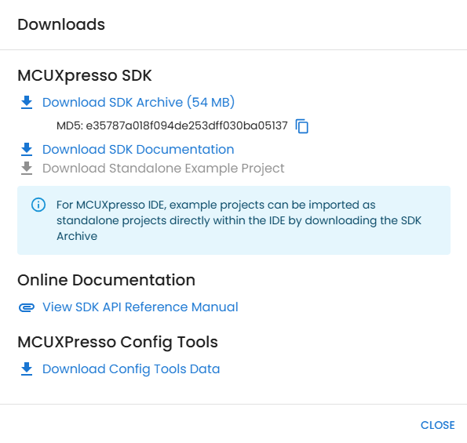
c

Installing the SDK in the IDE
The installation process of the IDE is straightforward. You just need to make sure to have Administrator access in the user running the installation and accept all the drivers installation prompts.
First time you run the IDE you’ll be prompted where you want to start your workspace. This will be the default location for your new projects (see next picture), hit the “Launch” button to start the IDE.
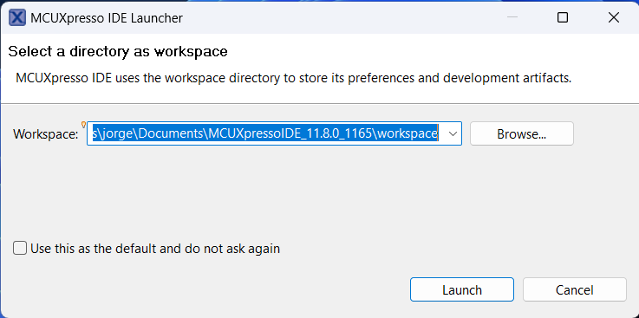
c
Once on the IDE you must change your view to “Develop Perspective”. To do that you must follow the path shown in the next picture. You can also hit on the “IDE” button, if shown, the next screen should be the same regardless of the option you chose.
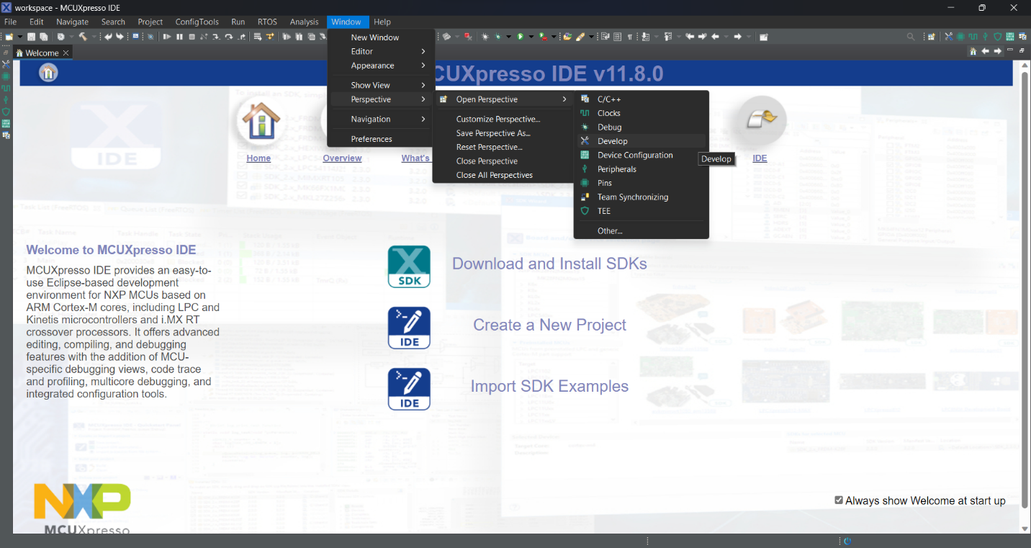

c
c
c
c
In the next screen you must make sure to select the “Installed SDKs” tab as shown in the next picture, and then drag and drop the zip file with the SDK that you downloaded in the previous step to the highlighted area.
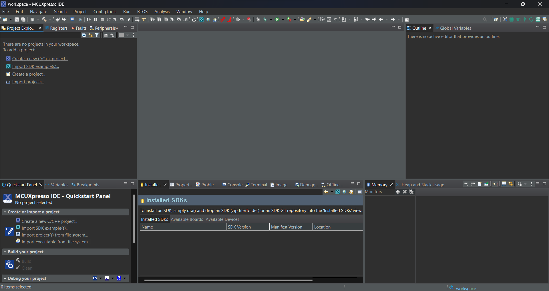

c
Next, you’ll be prompted with the window shown below and you just need to simply hit the “OK” button.
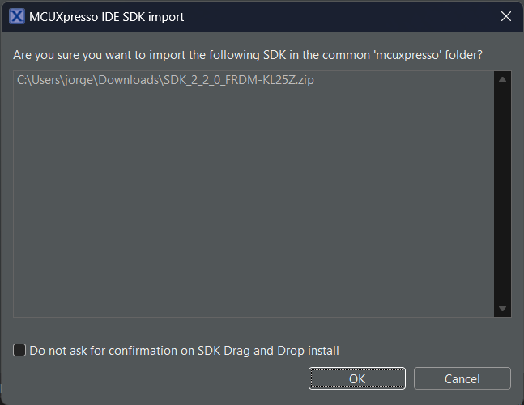
c
Now the SDK should be installed, and you can create a new project from one of the examples shipped with the FreeRTOS middleware and then edit it to your custom code.

Running an example to check for proper installation.
To create a new project, click on File->New->Create a new C/C++ project… as shown in the following image.
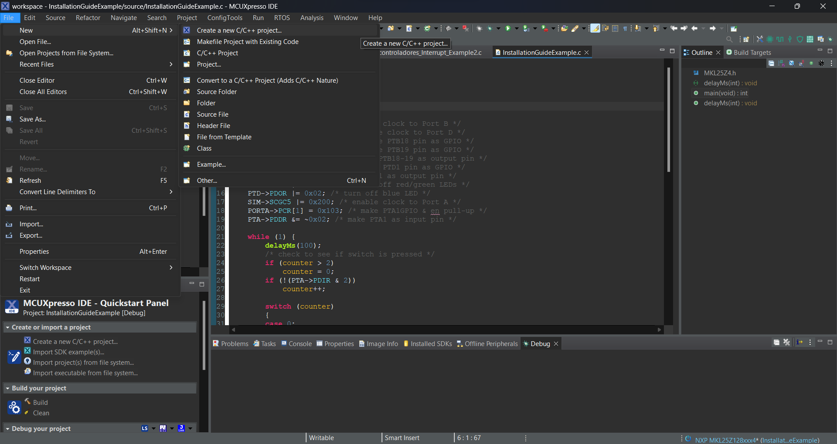
c
c
c
The new project wizard will launch, then you should select the frdmkl25z board as shown below and then click on “Next” button.
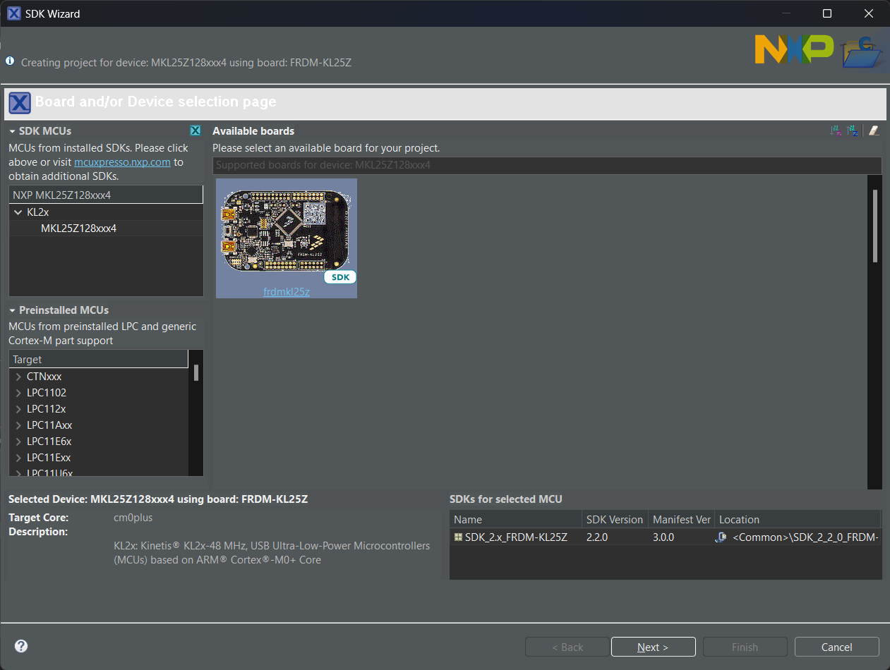
c
c
c
In the next window you should set a name and sufix for the project, leave all other options in default setting and hit the “Finish” button (see image below).
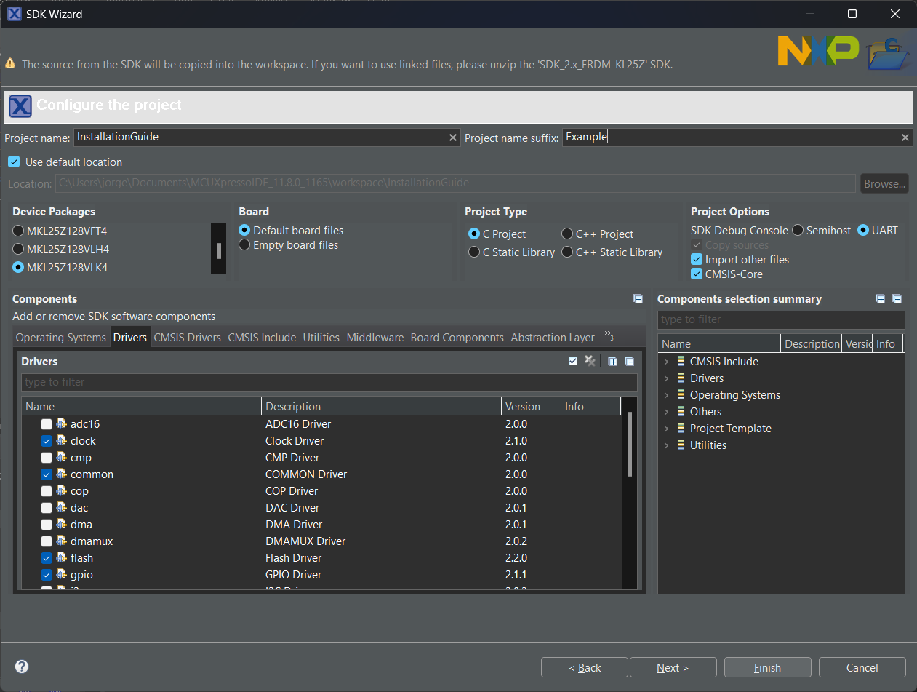
c
c
c
The project is created in your workspace and the main file that stores the code of your application should be openned in the main window of MCUExpresso. Now you should replace all code on the file by the code provide in the annexes.
To program the code to your board you need to first make sure that the board is properly connected to your pc, all drivers are installed as shown in the beginning of this tutorial and that you have opened the project on your workspace.
If you want to debug your code, then you should click on Run->Debug As->3 PEMicro probes as shown in following image.
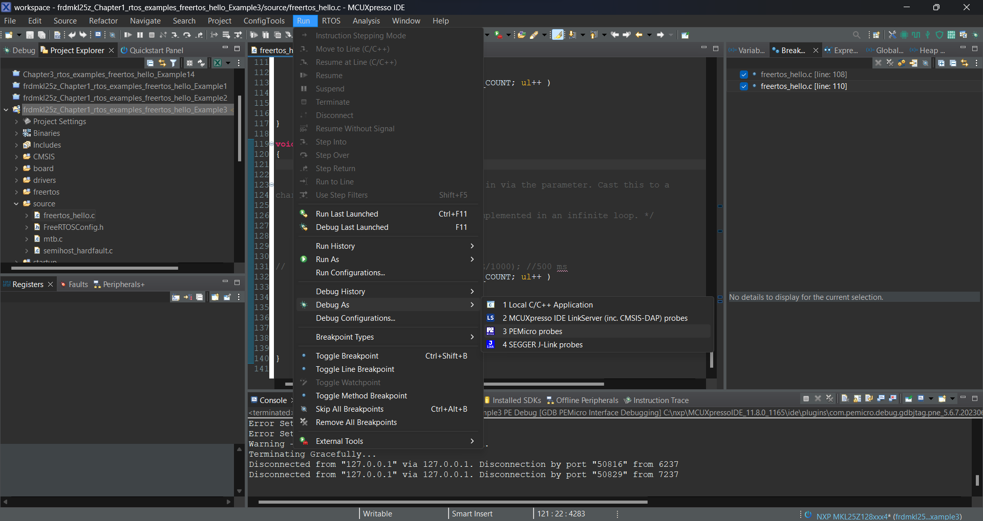
Once you start debugging by default the program will stop at the first line of executable code, you can then hit continue to see the execution of your program. If you unplug and plug the board again, the program will be already downloaded and should run without interruptions.
If you just want to upload your code and start running your application, then in the Quickstart Panel located in the bottom left corner, you should scroll down until your reach the Debug your project section, then click on the black arrow of the second icon to display a dropdown menu, then click on the third option, called Program flash action using PEMicro probes, as shown in the following image.
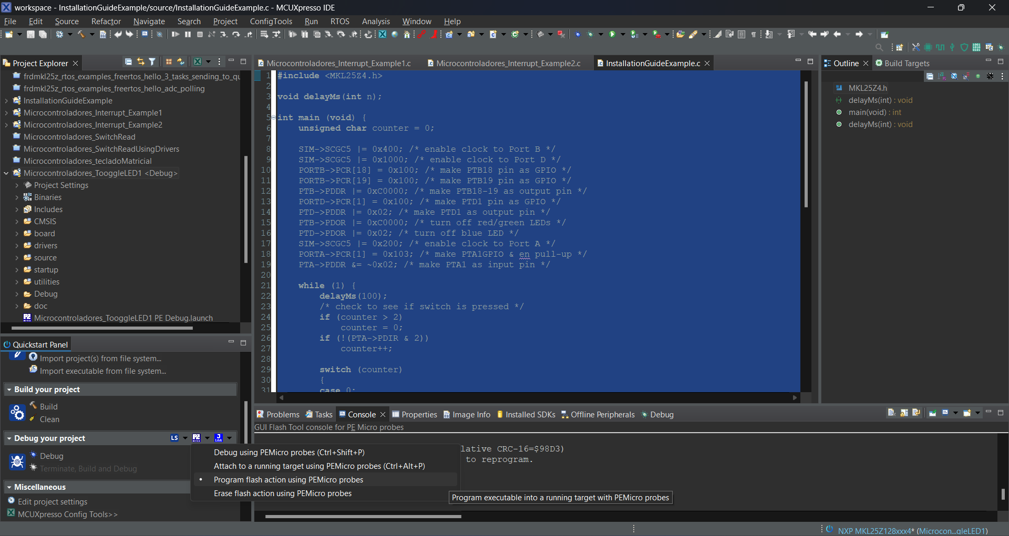

Annexes

Example application code
#include <MKL25Z4.h>
void delayMs(int n);
int main (void) {
unsigned char counter = 0;
SIM->SCGC5 |= 0x400; /* enable clock to Port B */
SIM->SCGC5 |= 0x1000; /* enable clock to Port D */
PORTB->PCR[18] = 0x100; /* make PTB18 pin as GPIO */
PORTB->PCR[19] = 0x100; /* make PTB19 pin as GPIO */
PTB->PDDR |= 0xC0000; /* make PTB18-19 as output pin */
PORTD->PCR[1] = 0x100; /* make PTD1 pin as GPIO */
PTD->PDDR |= 0x02; /* make PTD1 as output pin */
PTB->PDOR |= 0xC0000; /* turn off red/green LEDs */
PTD->PDOR |= 0x02; /* turn off blue LED */
SIM->SCGC5 |= 0x200; /* enable clock to Port A */
PORTA->PCR[1] = 0x103; /* make PTA1GPIO & en pull-up */
PTA->PDDR &= ~0x02; /* make PTA1 as input pin */
while (1) {
delayMs(100);
/* check to see if switch is pressed */
if (counter > 2)
counter = 0;
if (!(PTA->PDIR & 2))
counter++;
switch (counter)
{
case 0:
//turn on green LED
PTB->PCOR = 0x80000;
//turn off all other LEDS
PTB->PSOR = 0x40000;
PTD->PSOR = 0x02;
break;
case 1:
//turn on red LED
PTB->PCOR = 0x40000;
//turn off all other LEDS
PTB->PSOR = 0x80000;
PTD->PSOR = 0x02;
break;
case 2:
//turn on blue LED
PTD->PCOR = 0x2;
//turn off all other LEDS
PTB->PSOR = 0xC0000;
break;
default:
break;
}
}
}
/* Delay n milliseconds
* The CPU core clock is set to MCGFLLCLK at 41.94 MHz
in SystemInit().*/
void delayMs(int n) {
int i;
int j;
for(i = 0 ; i < n; i++)
for (j = 0; j < 5000; j++) {}
}

